OOP Assignment

Nipun Bajracharya
Westcliff University
Module: C++ and OOP
Professor Chandra
August 3,2026

OOP Assignment
1. Write differences between Procedure oriented and object oriented programming.
Procedure Oriented Programming (POP) A procedure oriented focus concentrates on the algorithm details and function used in solving a particular problem. It adopts a top-down design approach and decomposes a complete program into subprograms called functions that can be viewed as efficient modules. In this model data and functions are two separate concepts i.e. data is free floating (globally) across the complete program and cannot be kept isolated. Due to this, data is more easily accessible for random changes and data security is not provided through access specifiers. Procedure oriented programming is quite effective for small scale, simple projects, but difficult to extend or secure when the project expands. Examples of procedure oriented programming languages are C, Pascal and Fortran.
Object-Oriented Programming (OOP) structures a program around real-world entities called objects, which bundle both data and behaviors into a single unit. It uses a bottom-up approach, focusing heavily on data security and protection rather than just the sequence of actions. OOP introduces core principles like encapsulation to hide data, inheritance to reuse code, and polymorphism to allow for function overloading. Access specifiers like private and public ensure that data cannot be accessed or altered by unauthorized outside functions. This modular design makes OOP highly scalable, easy to modify, and the industry standard for large, complex enterprise software. Common examples of OOP languages include Java, C++, and Python.
2. Explain features of Object Oriented Programming.
OOP has only a handful of defining features.

One of these is that classes are templates for objects, and objects are instances of classes.Encapsulation packages data and methods into one object and conceals information from outside access. Closely related to this is abstraction, which conceals implementation complexity and exposes only the required features to the user.Inheritance enables the creation of a class derived from an existing class, facilitating code reuse.
Polymorphism permits a function or an operator to have many forms, providing the ability for the same interface to be used for different underlying data types, achieving "one interface, multiple methods".This is possible through dynamic binding.
All of these features together give you a very powerful method of creating flexible, reusable, and maintainable software with object-oriented programming.
3. Write a program to demonstrate the use of custom namespaces. Create two namespaces,
'Metric' and 'Imperial'. Inside 'Metric', define a function to convert kilometers to meters.
Inside 'Imperial', define a function to convert miles to feet. Call both functions from the
main() block.
Code:
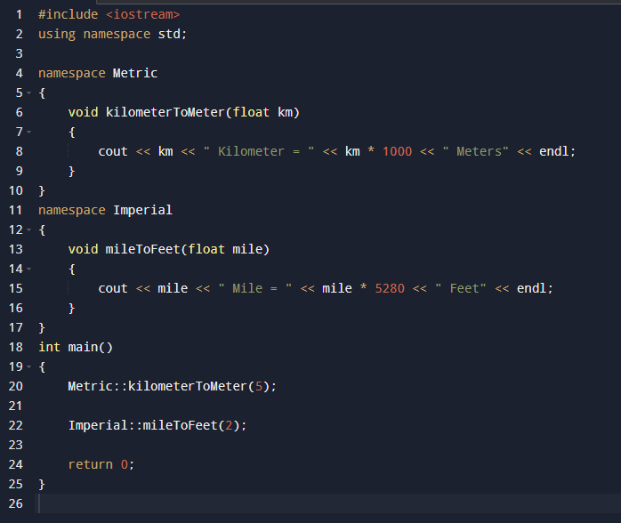
Output
5 kilometer = 5000 meters
4.Write a program that reads a floating-point number representing a total bill amount.
Display the bill using I/O manipulators (setw, setfill, setprecision, and showpoint) to
format the output nicely with exactly two decimal places, right-aligned in a field width
of 12, padded with asterisks (*).
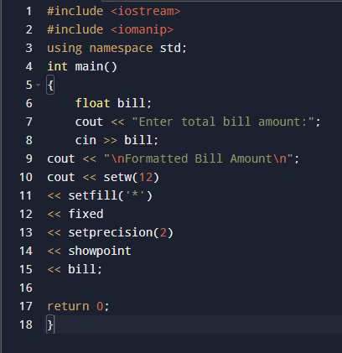
Output

5) Write a program that uses 'new' and 'delete' operators to dynamically allocate an array of
integers based on user-defined size. Input the elements, calculate their sum and average,
print the results, and then free the allocated memory to prevent memory leaks.

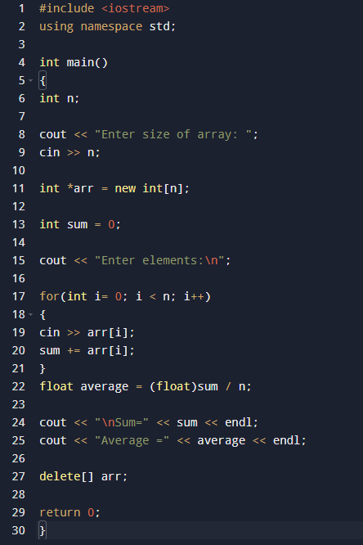
Output
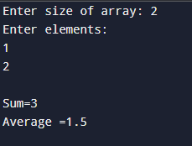
6)Create a program to calculate the area of different shapes using Function Overloading.
Implement three overloaded functions named 'area' to calculate:
a) Area of a circle (takes 1 float argument)
b) Area of a rectangle (takes 2 int arguments)
c) Area of a triangle (takes 3 float arguments using Heron's formula)

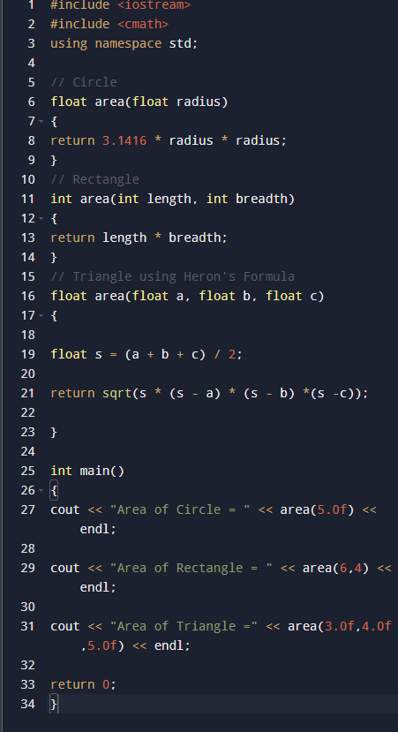
Output
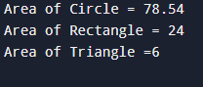
7) Write an inline function to find the maximum of three numbers. Test this function in
main() by passing different sets of numbers and explain via code comments how inline
functions differ from normal functions regarding execution overhead.

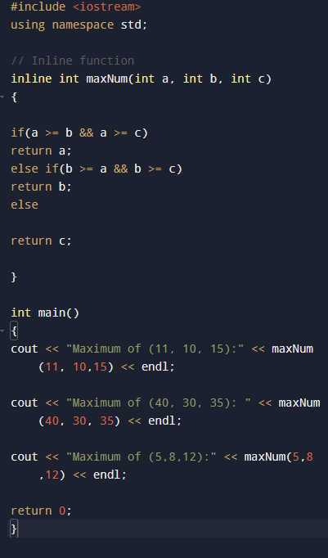
Output
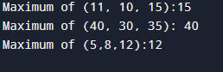
8) Write a function called 'amountCalc()' that accepts principal, time (years), and rate. Set
the default argument for the rate to 3.5%. Test the function by calling it with two
arguments (using default rate) and three arguments (overriding the default rate).

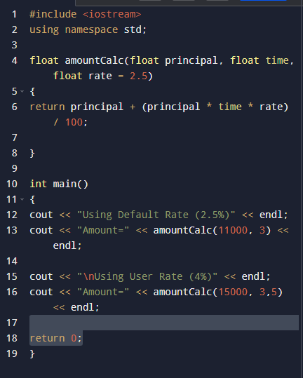
Output
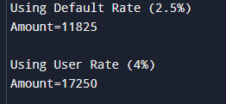
9) Write a program to swap two integer variables using Pass by Reference. Print the values
before and after swapping in the main() function to prove that the original variables were
Modified.

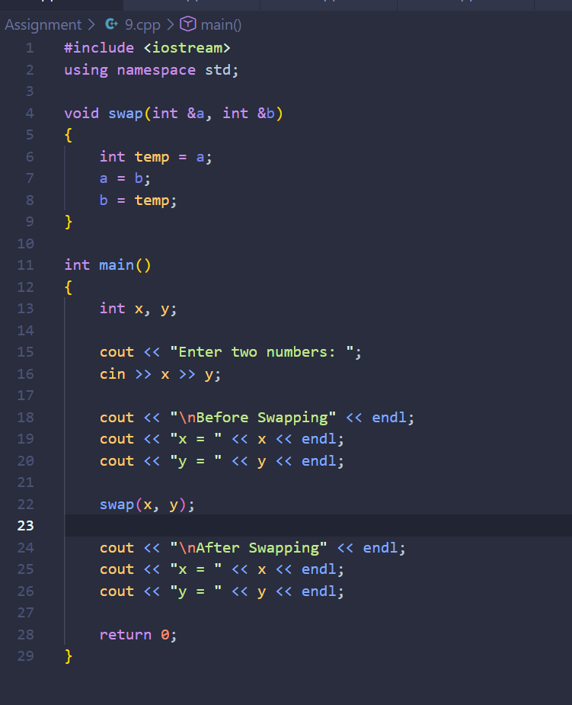
Output
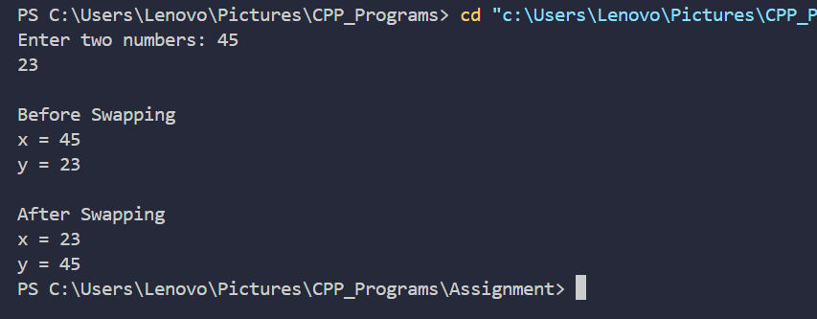
10) Create a program that demonstrates Return by Reference. Write a function 'maxRef(int
&x, int &y)' that returns a reference to the larger of the two variables, and use it on the
left-hand side of an assignment operator in main() to modify its value (e.g., maxRef(a, b)
= 100;).

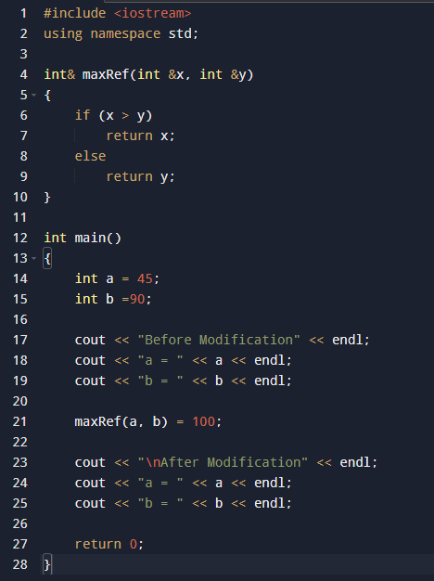
Output
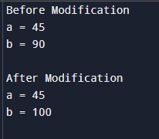
11)Write a program to illustrate the difference between 'automatic' (local), 'static', and
'global' storage classes by tracking how many times a particular function has been called
throughout the program execution.

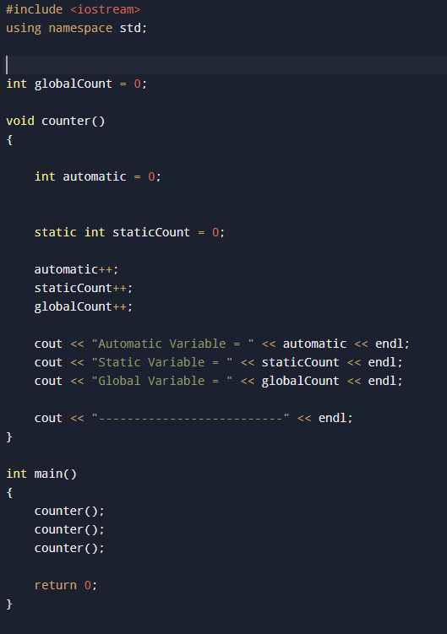
Output
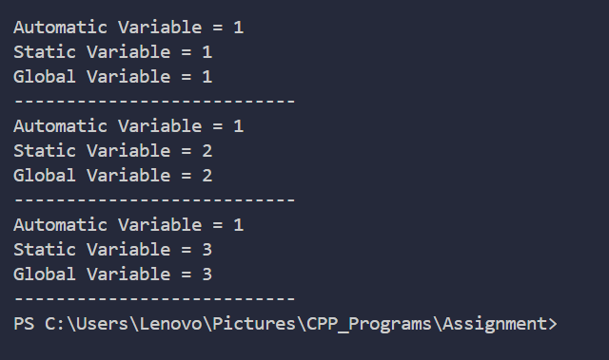

12)Write a program to declare an integer variable, an integer pointer, and a pointer-to-pointer
(double pointer). Initialize them appropriately and print the address and value of the
variable using all three identifiers.

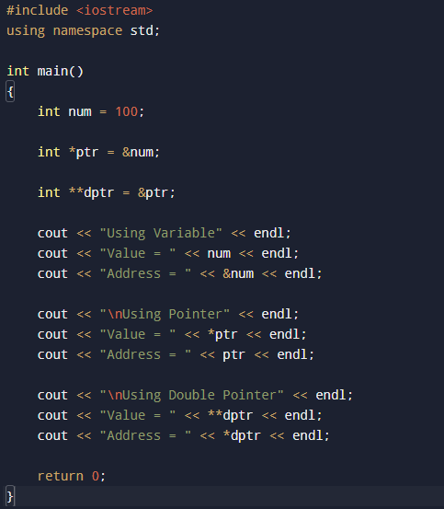
Output
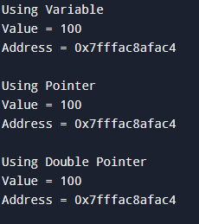
13)Write a program to find the largest and smallest element in an array of n integers using
pointers.Do not use array indexing (e.g., arr[i]); instead, use pointer arithmetic (e.g.,
*(ptr + i)).

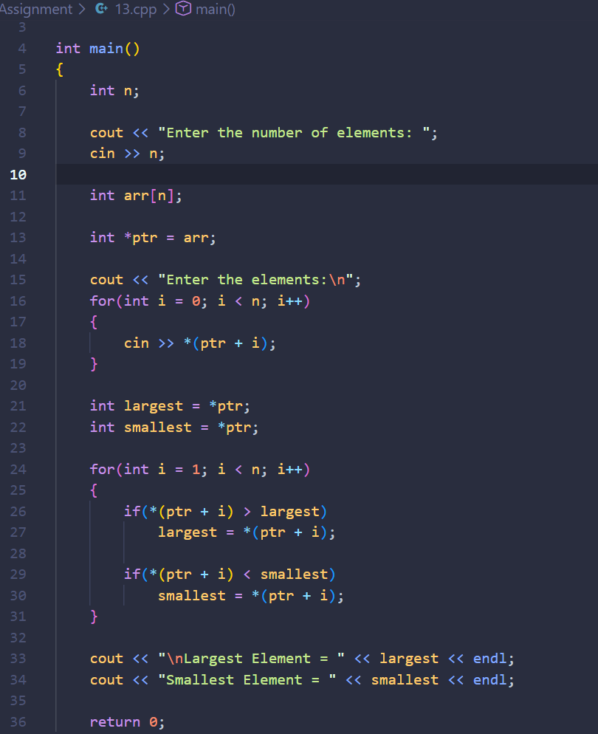
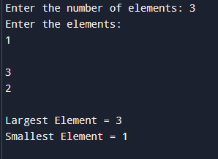
14)Write a program to concatenate two strings using pointers without using any standard
library functions like strcat().

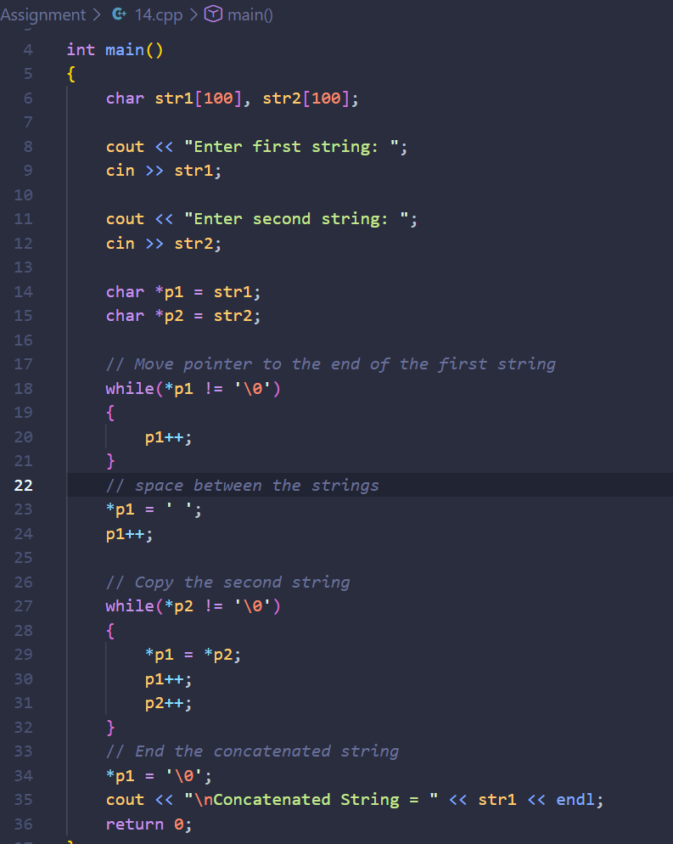
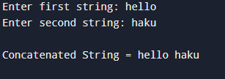
15) Create a function called 'updateSalary(float *salary, float bonus)' that accepts a pointer to
a salary variable and increases it by the bonus amount. Demonstrate Pointer and Function
interaction by calling this from main().

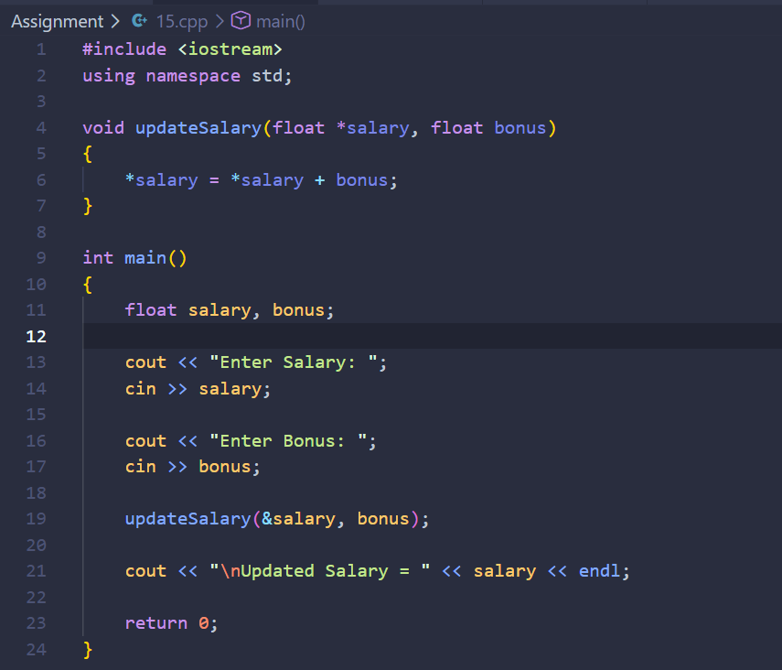
Output
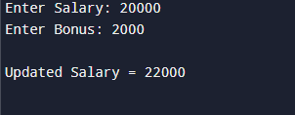
16) Write a program that inputs an array of 5 integers and displays them in reverse order
using a pointer initialized to the last element of the array and decrementing it
sequentially.

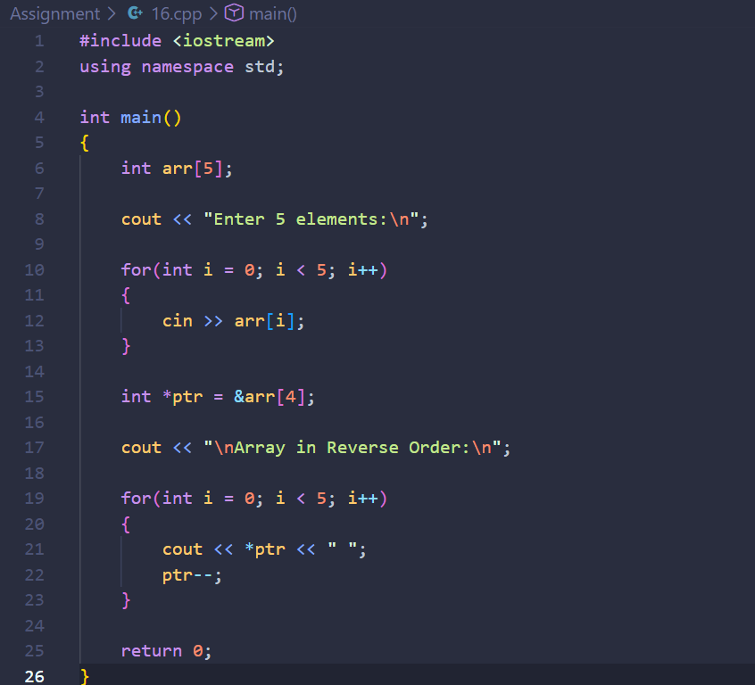
Output
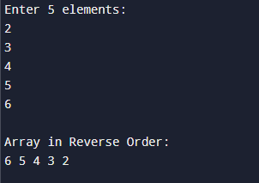
17) Write a comprehensive C++ program that combines type conversion and control
statements: Prompt the user for an implicit type conversion example (e.g., assigning a
float to an int) and use a switch-case statement to let the user choose whether to perform
an explicit type cast (static_cast<int>) or view the truncated value.

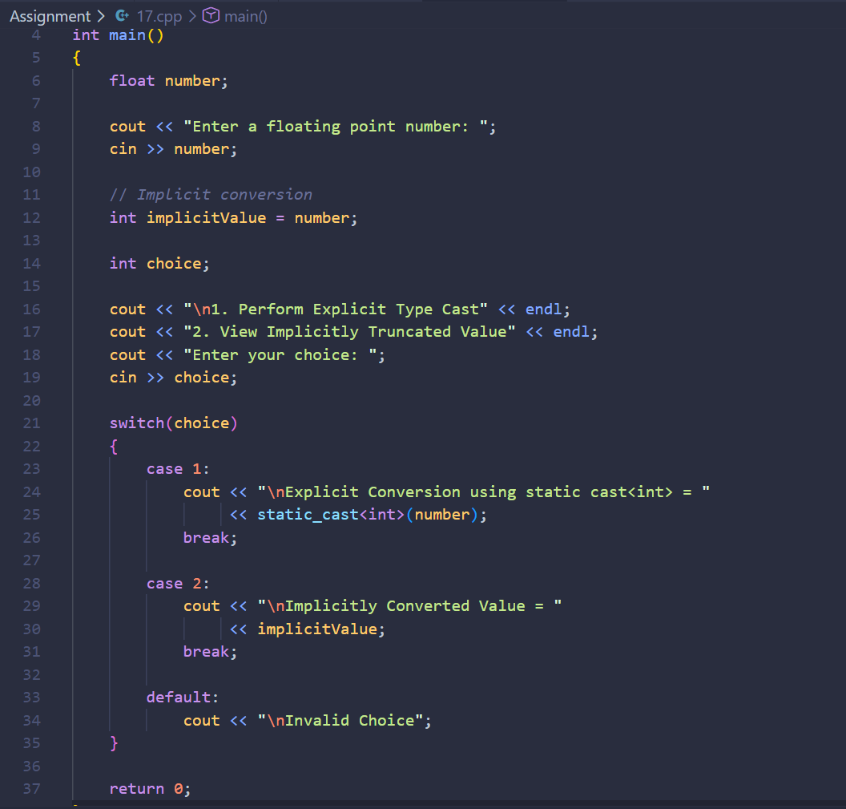
Output
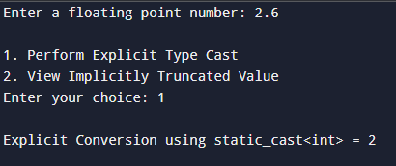
GitHub link:-https://github.com/bajracharyanipun/C-.git

